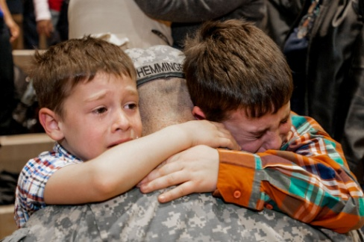

Children of Deployed Military Parents
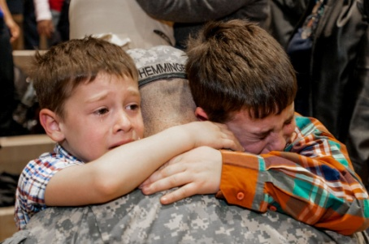
“Deployment involves an extended separation from a primary caregiver, and a separation that may be fraught with danger for the service member, and worry for his/her
“Deployment involves an extended separation from a primary caregiver, and a separation that may be fraught with danger for the service member, and worry for his/her
family.” (6)

Why is this important to learn about?
“Nearly 2 million children live in military
families and 700,000 have had a
parent deployed, at least 19,000
have had a parent wounded in
action, and more than 2,200 have
lost a parent in war.” (10)

“Deployment involves an extended separation from a primary caregiver, and a separation that may be fraught with danger for the service member, and worry for his/her
family.” (6)

Why is this important to learn about?
“Nearly 2 million children live in military
families and 700,000 have had a
parent deployed, at least 19,000
have had a parent wounded in
action, and more than 2,200 have
lost a parent in war.” (10)

family.” (6)

Why is this important to learn about?
“Nearly 2 million children live in military families and 700,000 have had a parent deployed, at least 19,000 have had a parent wounded in action, and more than 2,200 have lost a parent in war.” (10)

What Children May Experience Due to Parental Deployment:
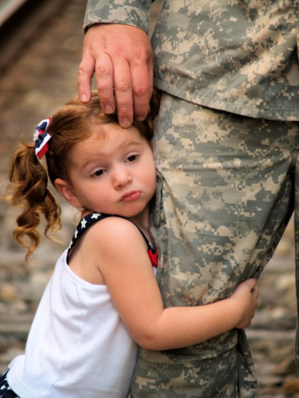
- Difficulty managing feelings and emotions (10)
- Higher level of anxiety including separation and general anxiety (10)
- Behavior problems e.g. Increase in conduct problems (10)
- Struggle developing relationships with adults, peers, and teachers (10)
- Academic issues: specifically lower math and reading scores, missing a lot of school, and homework assignments (6,10)
- Trouble sleeping has been found in 56% of children with deployed parents (10)
- Stress that comes from relocation and school transition (6)
- Attention- seeking behavior (6)
- Substance Abuse issues (4)
- Psychological problems (4)
- Emotional Problems (4)
- Psychosocial problems- 2.5 times higher than the norm (6)
- Depression (2)
- Stress (6)
- Additional challenges due to frequent relocation (6)

What Can Counselors Do?
- Starting or getting the family involved in small groups/support groups for children and family members. (2, 16)
-Children talking with their siblings /people who have similar experiences (7)
- Counselor and parent partnership check-ups/check-in regarding the child and family (2, 14)
- Counselors can start/get the parent involved in parent education groups (2, 6)
- Get the child involved in a mentorship program (2)
- Teach and talk about emotion regulation and coping strategies with children (6)
What Can Parents Do?
1) Seeking support from community and family members can lessen the stress military families’ face.
If possible living on base or in a military community has been found to help (6)
2) Set limits with children (boundaries), keep a routine within the home
(6, 14)
3) Make sure to be aware of your own emotions, practice self-care, and seek support with coping. (2)
4) Encourage child(ren) to journal, make scrap books, write letters, make cards, draw pictures, have a calendar; to help them cope with their feelings. (2, 14)
5) Be involved in your child’s education. (2,14)
6) Use the internet to stay in contact with the deployed parent e.g. skype (6, 7)
Helpful Resource for Kids: MilitaryKidsConnect.org
Children of Divorced Parents

Why is this important?
“Half of all American children will witness the breakup of a parent's marriage.” (19)

“Research has found that children whose parents have divorced have been found to have more psychological problems, than a child who has lost a parent due to death.” (1)

What Children May Experience Due to Divorce:
- Internalizing issues ( e.g. anxiety, depression, emotional maladjustment, guilt, conflicting feelings of loyalty towards parents , and confusion) (17)
- Externalizing problems (e.g. acting out/arguing, rule-breaking behavior, aggressive behavior, and disruptive conduct) (17)
- Difficulties communicating with others, which may turn into antisocial behavior (16)
- Relationship problems with parents, and loved ones (9)
- Academic problems (3) (younger children suffer more academically, but older children are more likely to drop out of school compared to their peers). (11)
-“Conflict in the home causes children to become stressed which can then affect the child’s brain in the area in charge of memory and learning. “ (18)
- Psychological problems (1)

What Can Counselors Do To Help?
1) Play therapy-through the play process children are able to use toys to work through what they are dealing with internally . (8)
2) Teaching children coping strategies has been found to help boost a child’s confidence and allows them to adjust more quickly to divorce. (3)
3) Counselors should stay up to date on recent research to learn and adopt new activities to support students’ needs. (3)
4) Collaboration through consultations with teachers, parents, and the counselor (3).
5) Start support groups-help children learn coping strategies, allow for the situation to be normalized and decrease child self-blame (13).
6) Prevention and Intervention Programs have been found to have positive effects in children of divorced parents including: “fewer sexual partners, lower rates of mental disorder, lower levels of internalizing and externalizing problems, substance abuse, higher GPAs and higher self-esteem” (15).

After the Divorce Parents Can:
- Establish a new set of routines to create some predictability for the child.(12)
- Allow the child to come up with their own rituals so that the child can feel a sense of control. (12)
- Frequently remind your child that you love him/her and want the new situation to work. (12)
- Be sure not to talk badly about or criticize the other parent around your child. (5)
- Get involved in Child-Parent Relationship Therapy. It has been found to decrease internal and external problems and increase self-esteem & confidence. It also helps parents learn parenting skills. (17).

References
1) Children Divorce Statistics. (2013). Children Divorce Statistics. Retrieved by www.children-and-divorce.com/children-divorce-statistics.html
2) Cole, R.F. (2012). Professional school counselors’ role in partnering with military families during the stages of deployment. Journal of School Counseling. 10(7). 1-23. Retrieved from Ebscohost.
3) Connelly,M.E., Green, E.J. (2009). Evidence-based counseling interventions with children of divorce: Implications for elementary school counselors. The Chicago school of professional psychology. Retrieved from Ebscohost.
4) Elliot, O. (2013). Children and siblings of deployed troops are at greater risk for substance abuse. EPMagazine. www.eparent.com/EPMagazine. Retreived from Ebscohost.
5) Foulkes-Jamison, L. (2001). The Effects of Divorce on Children. Clinical Psychology Associated of North Central Florida. Retrieved from http://cpancf.com/articles_files/efffectsdivorceonchildren.asp.
6) Gewirts, A.H., Zamir, O. (2014). The impact of parental deployment to war on children: The crucial role of parenting. Advances in child development and behavior. (46) Retreived from Ebscohost
7) Houston, J.B., Pfefferbaum, B., Sherman, M.D., Melson, A.G., Brand, M.W. (2013). Family communication across the military deployment experience: child and spouse report of communication frequency and quality and associated emotions, behaviors, and reactions. Journal of loss and trauma. Doi: 10.1080/15325024.2012.684576. Retreived from Ebscohost
8) How play therapy can help children overcome divorce. (2004). Counseling Children. Retrieved from http://counselingchildren.net/how-play-therapy-can-help-children-overcome-divorce
9) Lansford, J.E. (2009). Parental divorce and children’s adjustment. Association for psychological science. 4(2). 140-149. Retrieved from Ebscohost.
10) Maholmes, V. (2012). Adjustment of children and youth in military families: toward developmental understanding. Child development perspectives. 6(4). Doi: 10.1111/j.1750-8606.2012.00256.x. Retreived from Ebscohost.
11) Molepo,L.S., Maunganidze, L., Mudhovozi, P., Sodi, T. (2010). Teacher ratings of academic achievement of children between 6 and 12 years old from intact and non-intact families. Perspective in education. 28(1).Retrieved from Ebscohost.
12) Pickhardt, C. (2011). Surviving (Your Child’s) Adolescence: The impact of divorce on young children and adolescents. Psychology Today. Retrieved from http://www.psychologytoday.com/blog/surviving-your-childs-adolescence/201112/the-impact-divorce-young-children-and-adolescents
13) Regev,R. , Ehrenberg, M. (2012). A pilot study of a support group for children in divorcing families: Aiding community program development and marking pathways to resilience. Journal of divorce & remarriage. 53, 220-230. doi:10.1080/10502556.2012.663271. Retrieved from Ebscohost.
14) Siegel,B.S.& Davis, B.E. (2013). Health and mental health needs of children in US military families. American Academy of Pediatrics. Doi:10.1542/peds.2013-0940. Retreived from Ebscohost.
15) Sigal, A.B., Wolchick, S.A., Tein, J., Sandler, I.N. (2012). Enhancing youth outcomes following parental divorce: A longitudinal study of the effects of the new beginnings program on educational and occupational goals. Journal of Clinical & Adolescent Psychology. 41(2), 150-165. Doi: 10.1080/15374416.2012.651992. Retrieved from Ebscohost.
16) Sparks, S.D. (2011). Parents’ deployments found to exact a toll on students’ learning. Education Week. Retrieved from Ebscohost..
17) Taylor, D.D., Purswell,K., Lindo,N., Jayne,K., Fernando, D. (2011). The impact of child parent relationship therapy on child behavior and parent-child relationships: An examination of parental divorce. International Journal of Play Therapy. 20(3), 124-137. Doi: 10.1037/a0024469. Retrieved from Ebscohost.
18) Toronto, A.G. (n.d.) Conflict affects kid’s brains. Toronto Star (Canada). Retrieved from Ebscohost.
19) 32 Shocking Divorce Statistics. (2012). McKinley Irvin Family Law. Retrieved from http://www.mckinleyirvin.com/Family-Law-Blog/2012/October/32-Shocking-Divorce-Statistics.aspx?redirect_referrer=http%3a%2f%2fwww.pinterest.com%2fpin%2f297800594079986880%2f

